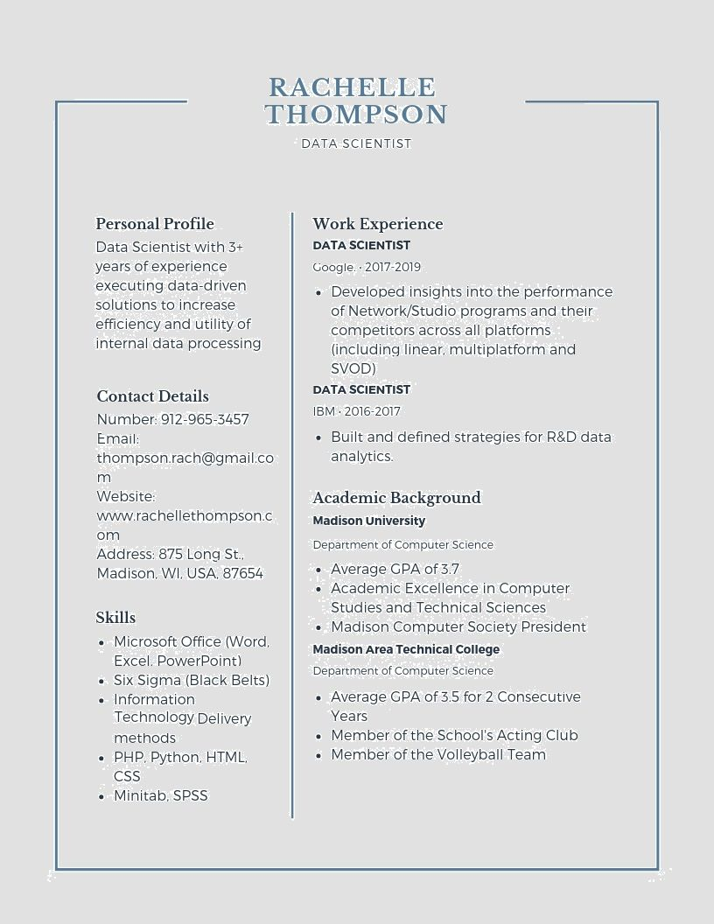
RACHELLE THOMPSON
DATA SCIENTIST
Personal Profile
Data Scientist with 3+ years of experience executing data-driven solutions to increase efficiency and utility of internal data processing
Contact Details
Number: 912-965-3457
Email:
thompson rach@gmail.co
m
Website:
www.rachellethompson.c
om
Address: 875 Long St.. Madison, WI. USA, 87654
Skills
Microsoft Office (Word, Excel, PowerPoint)
⚫ Six Sigma (Black Belts) • Information
Technology Delivery methods
⚫ PHP, Python, HTML,
CSS
Minitab, SPSS
Work Experience
DATA SCIENTIST
Google 2017-2019
• Developed insights into the performance of Network/Studio programs and their competitors across all platforms (including linear, multiplatform and SVOD)
DATA SCIENTIST
IBM. 2016-2017
• Built and defined strategies for R&D data analytics.
Academic Background Madison University
Department of Computer Science
Average GPA of 3.7
Academic Excellence in Computer Studies and Technical Sciences
Madison Computer Society President
Madison Area Technical College
Department of Computer Science
Average GPA of 3.5 for 2 Consecutive Years
Member of the School's Acting Club • Member of the Volleyball Team

